**D. Software Design Description**

**1. Design Overview**

This document describes the technical and user interface design of FFRS System. It includes the architectural design, the detailed design of common functions and business functions and the design of database model.

* The architectural design describes the overall architecture of the system and the architecture of each main component and subsystem.
* The detailed design describes static and dynamic structure for each component and functions. It includes class diagram, class explanations and sequence diagrams for each use cases.
* The database design describes the relationships between entities and details of each entity.
* Document overview:
  + Section 2: gives an overall description of the system architecture design.
  + Section 3: gives component diagrams that describes the connection and integration of the system.
  + Section 4: gives the detail design description which includes class diagram, class explanation and sequence diagram to details the application functions.
  + Section 5: describes screen design.
  + Section 6: describes a fully attributed ERD.
  + Section 7: describes algorithms.

**3. Component Diagram (Chua co lam)**

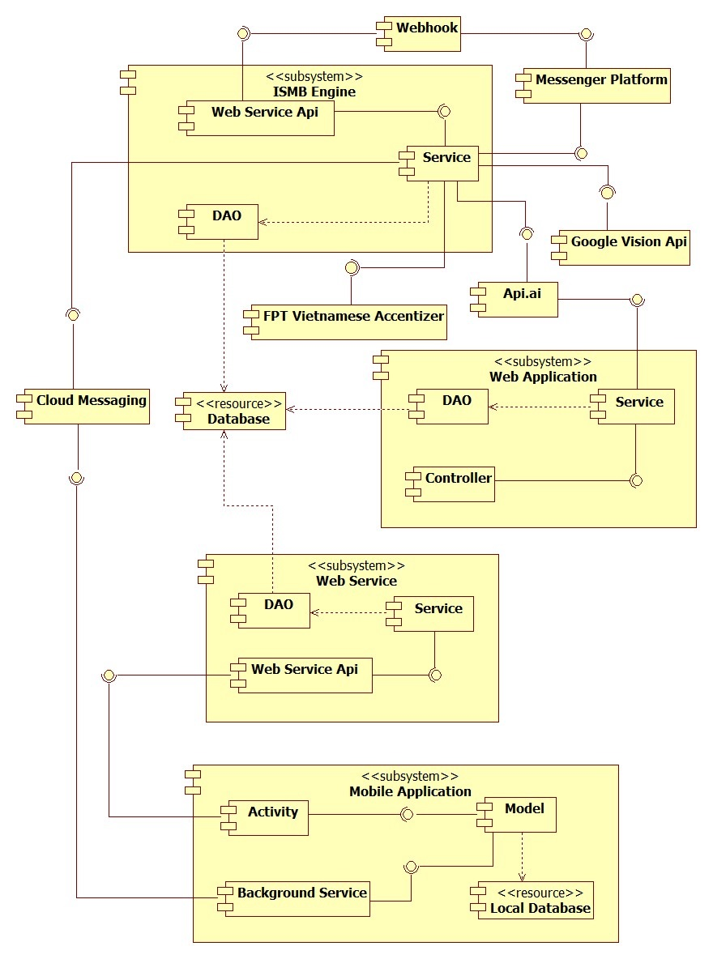

**Figure 57 – Component Diagram**

|  |  |
| --- | --- |
| **Component Dictionary: Describe Components** | |
| **Component Name** | **Description** |
| ISMB Engine | Component handles message from facebook users. |
| Web Application | Component to controll the system and training bot. |
| Web Service | Component provide api for mobile application to interact with the system. |
| Mobile Application | Component handles customers’ activities. |
| Database | Component to store data of the system. |
| Messenger Platform | Component to send message to and receive message from facebook user, provided by Facebook. |
| Webhook | Component handles interactions between Messenger Platform and ISMB Engine. |
| Google Vision Api | Component to detect product in images. |
| FPT Vietnamese Accentizer | Component to add Vietnamese accent into a senetence or phrase (Example: ca phe -> cà phê), provide by FPT. |
| Api.ai | Component to analyze natural language and response prametters that the system need to handle, proviced by Api.ai |
| Cloud Messaging | Coponent sends message from ISMB Engine to Mobile Application. |
| Controller | Component handles request from web. |
| Web Service Api | Component hanldes request from other components. |
| Service | Component handles business logic. |
| DAO | Component that do the interaction between the system and database. |
| Activity | Component handles customers’ interactions. |
| Model | Component handles business logic and interaction with local database. |
| Background Service | Component to run tasks in background. |

**Table 15 - Components Diagram Data Dictionary**

**5. User Interface Design**

**5.2 Mobile Application**

**1. Login**

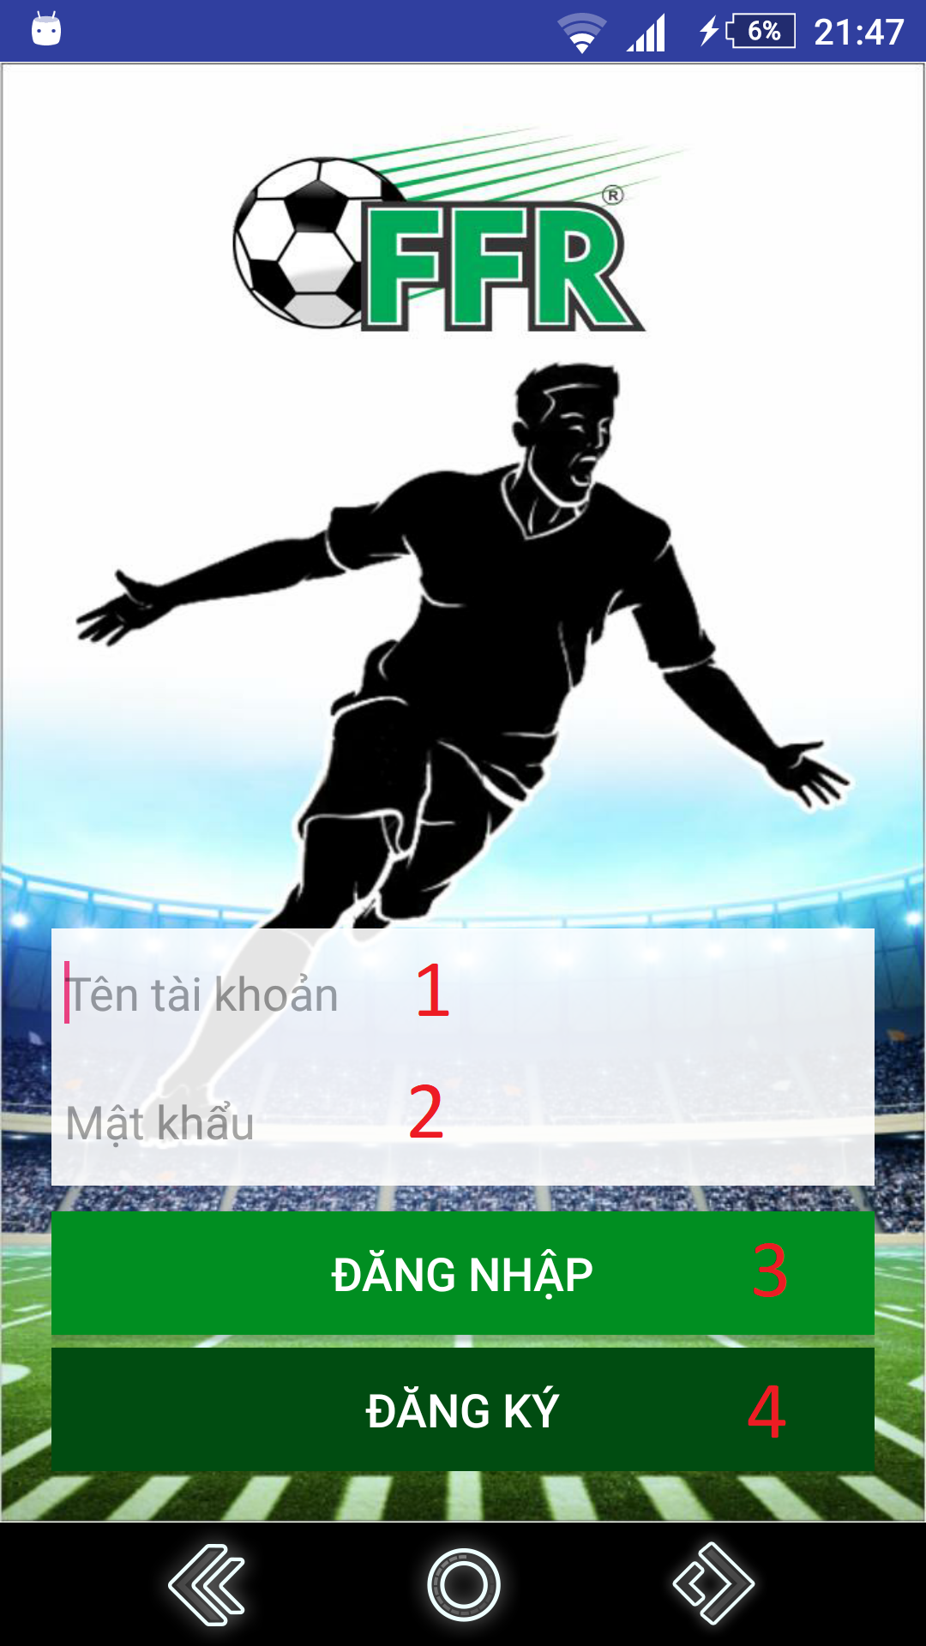

**Figure 99 - Login UI**

**Fields:**

|  |  |  |  |  |  |  |
| --- | --- | --- | --- | --- | --- | --- |
| **No** | **Field Names** | **Description** | **Read Only** | **Mandatory** | **Control Type** | **Data Type** |
| 1 | Username | Fill username | No | Yes | EditText | String |
| 2 | Password | Fill password | No | Yes | Password | String |

**Table 55 - <Mobile Application> Login Fields**

**Buttons/Hyperlinks**

|  |  |  |  |  |
| --- | --- | --- | --- | --- |
| **No** | **Function** | **Description** | **Validation** | **Outcome** |
| 3 | login | Login with username and password | N/A | Redirect to search field view |
| 4 | register | Create new account | N/A | Redirect to register view |

**Table 56 - <Mobile Application> Login Buttons/Hyperlinks**

**2. Register**

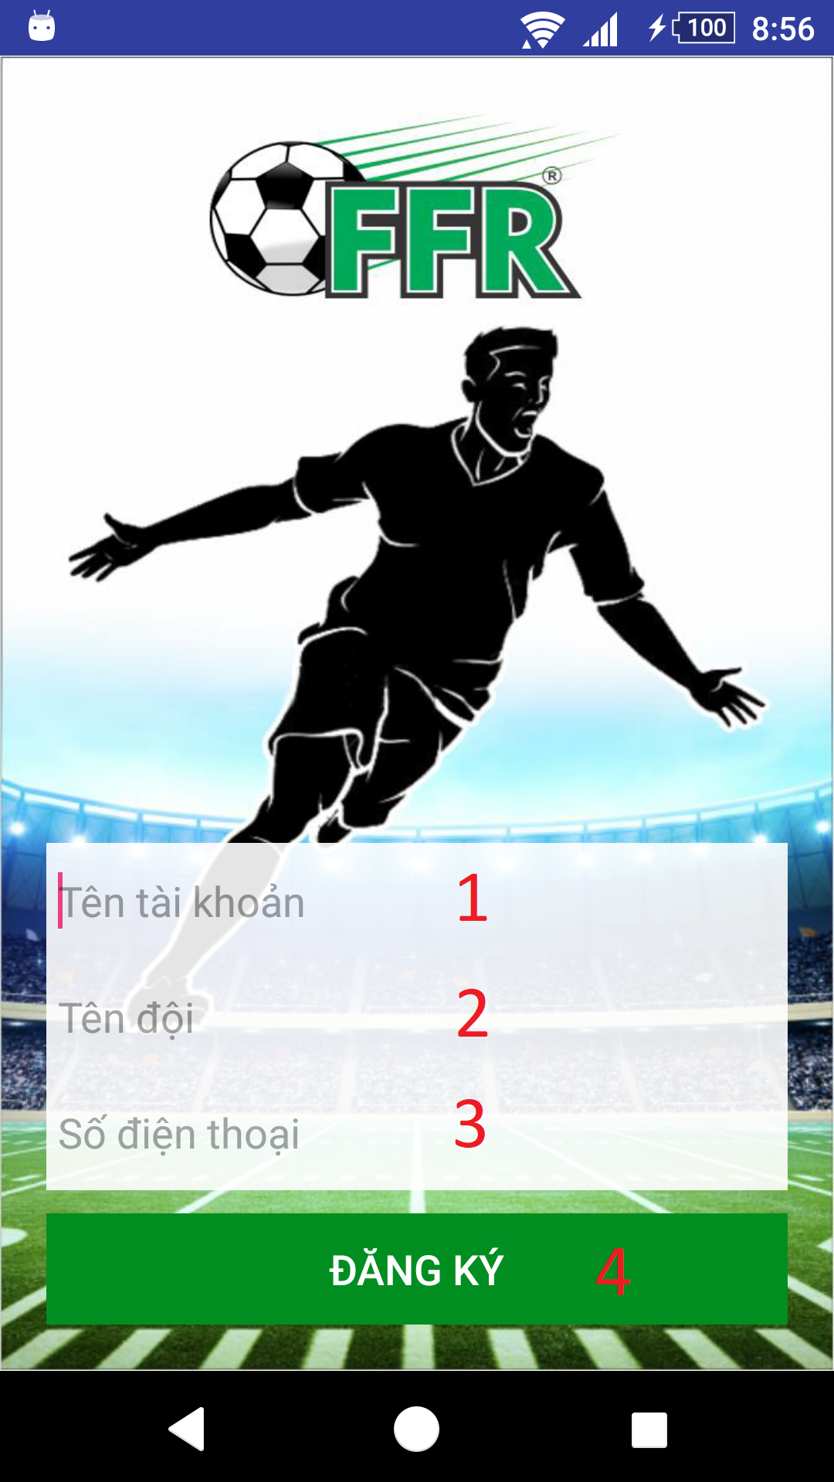

**Figure 100 - Register UI**

**Fields**

|  |  |  |  |  |  |  |
| --- | --- | --- | --- | --- | --- | --- |
| **No** | **Field Names** | **Description** | **Read Only** | **Mandatory** | **Control Type** | **Data Type** |
| 1 | username | Fill username | No | Yes | EditText | String |
| 2 | teamName | Fill user’s team name | No | Yes | EditText | String |
| 3 | phone | Fill phone | No | Yes | EditText | String |

**Table 57 - <Mobile Application> Register Fields**

**Buttons/Hyperlinks**

|  |  |  |  |  |
| --- | --- | --- | --- | --- |
| **No** | **Function** | **Description** | **Validation** | **Outcome** |
| 4 | register | Create new account | All fields required before summit | Redirect to search field view. |

**Table 58 - <Mobile Application> Register Buttons/Hyperlinks**

**3. Menu**

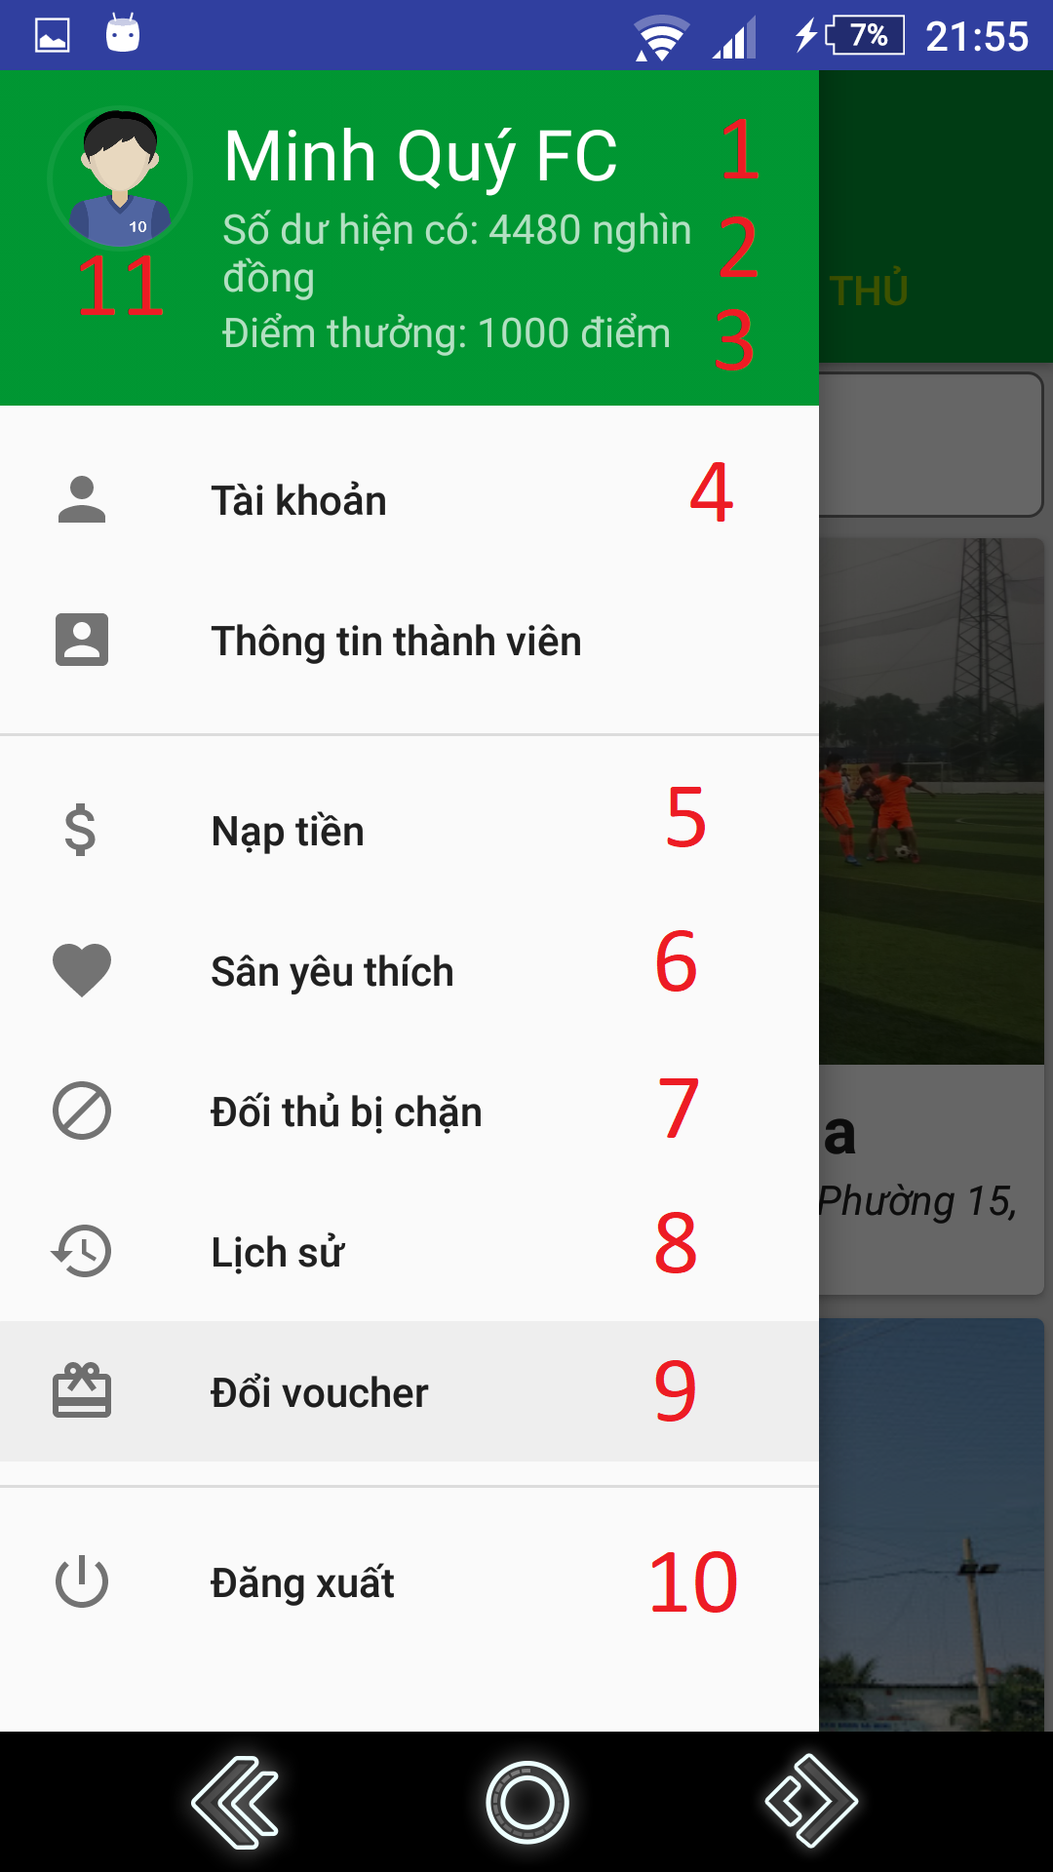

**Figure 101 - Menu UI**

**Fields**

|  |  |  |  |  |  |  |
| --- | --- | --- | --- | --- | --- | --- |
| **No** | **Field Names** | **Description** | **Read Only** | **Mandatory** | **Control Type** | **Data Type** |
| 1 | name | User’s team name | Yes | Yes | TextView | String |
| 2 | balance | User’s current balance | Yes | Yes | TextView | String |
| 3 | bonusPoint | User’s current bonus point | Yes | Yes | TextView | String |
| 11 | avatar | User’s avatar | Yes | Yes | Image | N/A |

**Table 59 - <Mobile Application> Menu Fields**

**Buttons/Hyperlinks**

|  |  |  |  |  |
| --- | --- | --- | --- | --- |
| **No** | **Function** | **Description** | **Validation** | **Outcome** |
| 4 | viewProfile | View user’s profile | N/A | Redirect to view profile view. |
| 5 | recharge | Go to recharge view | N/A | Redirect to recharge view. |
| 6 | viewFavoriteField | Show current area of user | N/A | Redirect to view location view. |
| 7 | viewBlacklist | Show user’s current blacklist | N/A | Redirect to view blacklist view. |
| 8 | viewHistory | Show user’s history | N/A | Redirect to view history view. |
| 9 | viewVoucher | Show available vouchers. | N/A | Redirect to view vouchers view. |
| 10 | logout | Logout of system | N/A | Redirect to login view. |

**Table 60 - <Mobile Application> Menu Buttons/Hyperlinks**

**4. Search Field**

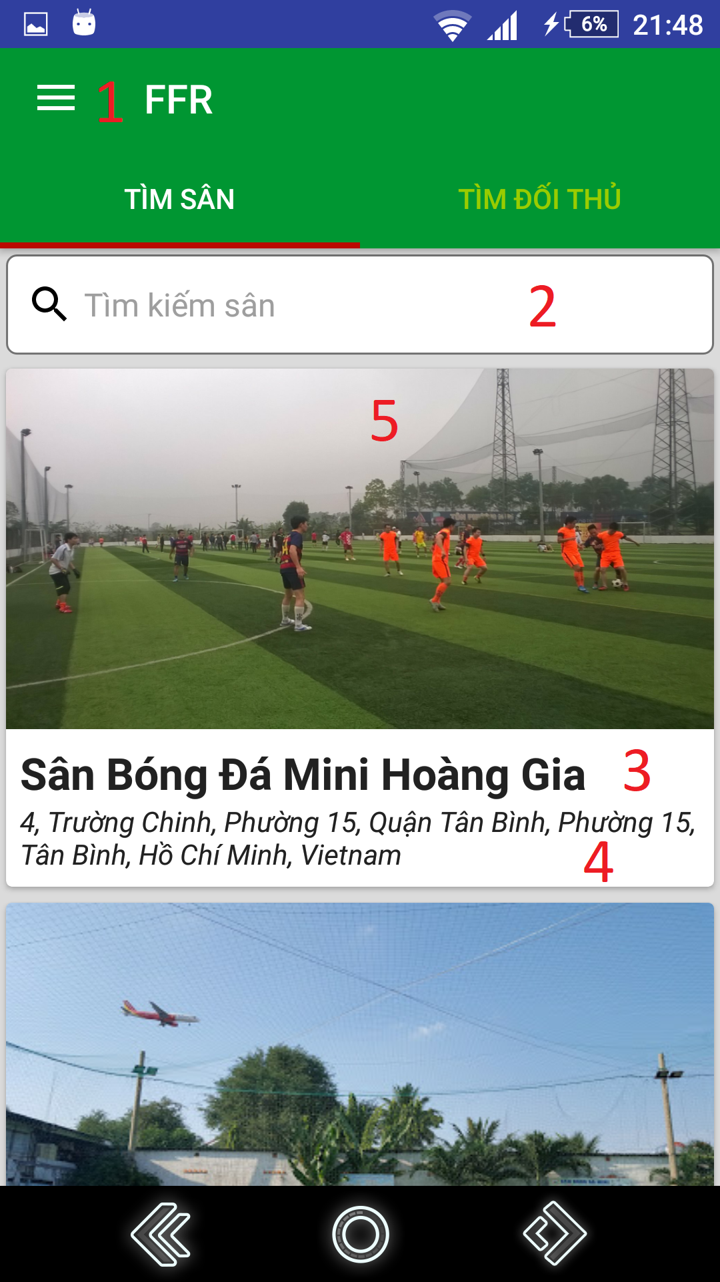

**Figure 102 – Search Field UI**

**Fields**

|  |  |  |  |  |  |  |
| --- | --- | --- | --- | --- | --- | --- |
| **No** | **Field Names** | **Description** | **Read Only** | **Mandatory** | **Control Type** | **Data Type** |
| 2 | searchText | Input search field name | No | No | EditText | String |
| 3 | fieldName | Field’s name | Yes | No | TextView | String |
| 4 | address | Address | Yes | No | TextView | String |
| 5 | image | Field’s image | Yes | No | ImageView | N/A |

**Table 61 - <Mobile Application> Search Field’s Fields**

**Buttons/Hyperlinks**

|  |  |  |  |  |
| --- | --- | --- | --- | --- |
| **No** | **Function** | **Description** | **Validation** | **Outcome** |
| 1 | showNavigation | Show navigation view | N/A | Show navigation bar |

**Table 62 -<Mobile Application> Search Field Buttons/Hyperlinks**

**5. Choose field’s free time**

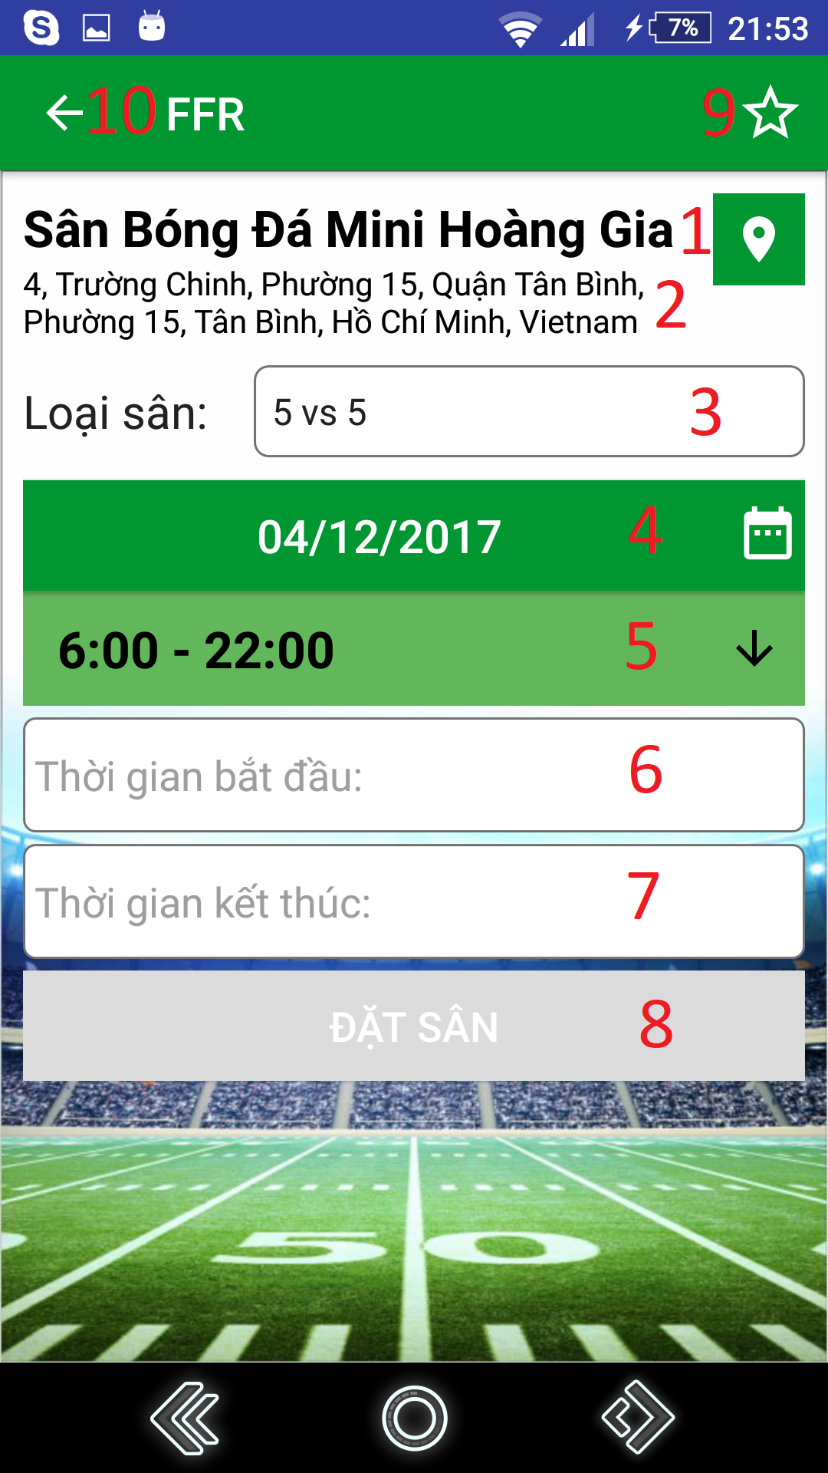

**Figure 103 - Choose field’s free time UI**

**Fields**

|  |  |  |  |  |  |  |
| --- | --- | --- | --- | --- | --- | --- |
| **No** | **Field Names** | **Description** | **Read Only** | **Mandatory** | **Control Type** | **Data Type** |
| 1 | fieldName | Field’s name | Yes | Yes | TextView | String |
| 2 | fieldAddress | Field’s address | Yes | Yes | TextView | String |
| 3 | date | Choose date to reserve | No | Yes | DatePicker | String |
| 4 | fieldType | Field’s type | No | Yes | Dropdown box | String |
| 5 | timeFrame | Time frame | Yes | Yes | TextView | String |
| 6 | startTime | Input start time of reservation | No | Yes | EditText | String |
| 7 | endTime | Input end time of reservation | No | Yes | EditText | String |

**Table 63 - <Mobile Application> Choose field’s free time Fields**

**Buttons/Hyperlinks**

|  |  |  |  |  |
| --- | --- | --- | --- | --- |
| **No** | **Function** | **Description** | **Validation** | **Outcome** |
| 8 | chooseTime | Set inputted time. | All fields required before summit | Redirect to view reservation detail view |
| 9 | setFavoriteField | Add/Remove field to/from favorite list | N/A | Show result message. |
| 10 | goBack | Go back to previous view | N/A | Show previous view |

**Table 64 - < Mobile Application > Choose field’s free time Buttons/Hyperlinks**

**6. View Reservation Details**

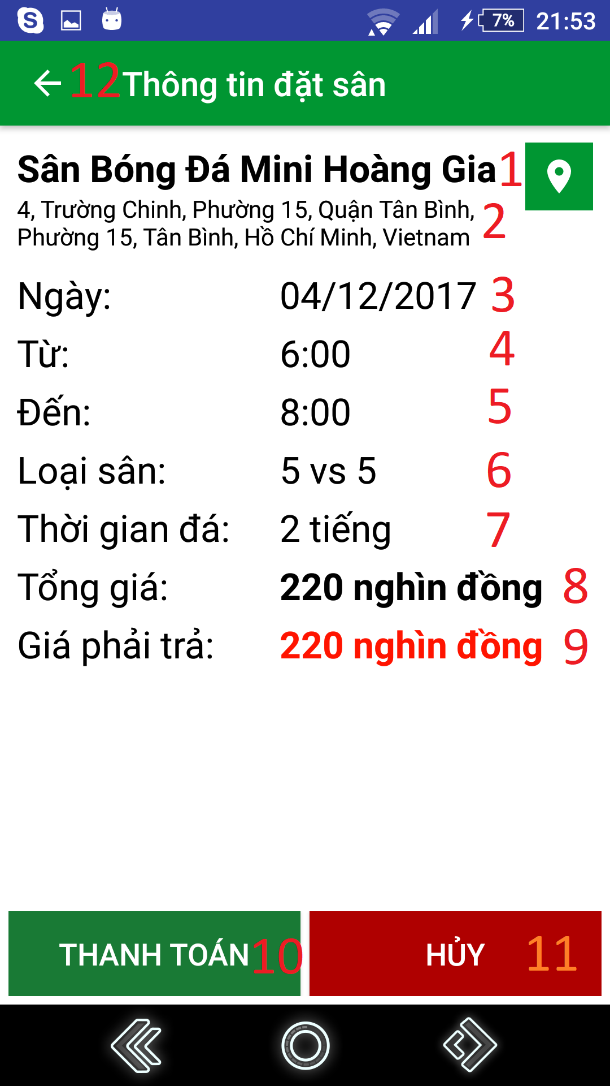

**Figure 104 - View Reservation Details UI**

**Fields**

|  |  |  |  |  |  |  |
| --- | --- | --- | --- | --- | --- | --- |
| **No** | **Field Names** | **Description** | **Read Only** | **Mandatory** | **Control Type** | **Data Type** |
| 1 | fieldName | Field’s name | Yes | Yes | TextView | String |
| 2 | fieldAddress | Field’s address | Yes | Yes | TextView | String |
| 3 | date | Reserved date | Yes | Yes | TextView | String |
| 4 | startTime | Start time | Yes | Yes | TextView | String |
| 5 | endTime | End time | Yes | Yes | TextView | String |
| 6 | fieldType | Field’s type | Yes | Yes | TextView | String |
| 7 | duration | Duration of match | Yes | Yes | TextView | String |
| 8 | totalPrice | Total price for the reservation | Yes | Yes | TextView | String |
| 9 | paidPrice | The price user must pay | Yes | Yes | TextView | String |

**Table 65 - <Mobile Application> View Reservation Details Fields**

**Buttons/Hyperlinks**

|  |  |  |  |  |
| --- | --- | --- | --- | --- |
| **No** | **Function** | **Description** | **Validation** | **Outcome** |
| 10 | Reserve | Reserve field | N/A | Show reservation result view |
| 11 | Cancel | Cancel reservation | N/A | Redirect to choose field’s free time view |
| 12 | goBack | Go back to previous view | N/A | Show previous view |

**Table 66 - <Mobile Application > View Reservation Details Buttons/Hyperlinks**

**7. Find opponent**

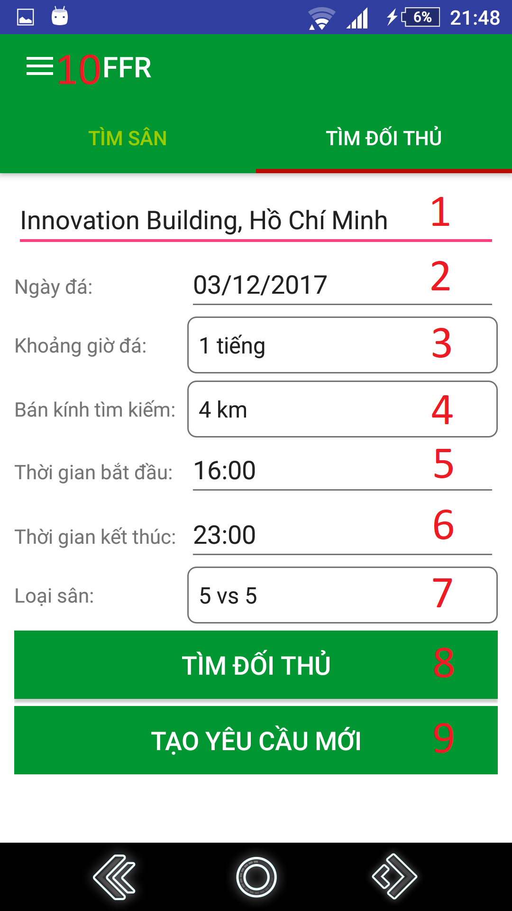

**Figure 105 – Find opponent UI**

**Fields**

|  |  |  |  |  |  |  |
| --- | --- | --- | --- | --- | --- | --- |
| **No** | **Field Names** | **Description** | **Read Only** | **Mandatory** | **Control Type** | **Data Type** |
| 1 | address | Input address where user wants to play | No | Yes | EditText | String |
| 2 | date | Choose date to reserve | No | Yes | Dropdown box | String |
| 3 | duration | Input duration | No | Yes | Spinner | String |
| 4 | distance | Input maximum distance for searching opponent | No | Yes | Spinner | String |
| 5 | startTime | Input start time for searching | No | Yes | EditText | String |
| 6 | endTime | Input end time for searching | No | Yes | EditText | String |
| 7 | fieldType | Field’s type | No | Yes | Dropdown box | String |

**Table 67 - <Mobile Application> Find opponent Fields**

**Buttons/Hyperlinks:**

|  |  |  |  |  |
| --- | --- | --- | --- | --- |
| **No** | **Function** | **Description** | **Validation** | **Outcome** |
| 8 | findOpponent | Find opponent | All fields required before summit | Show find opponent result view |
| 9 | createNewRequest | Create new request | All fields required before summit | Show create new request result view |
| 10 | showNavigation | Show navigation view | N/A | Show navigation bar |

**Table 68 - <Mobile Application> Find opponent Buttons/Hyperlinks**

**8. Matching result**

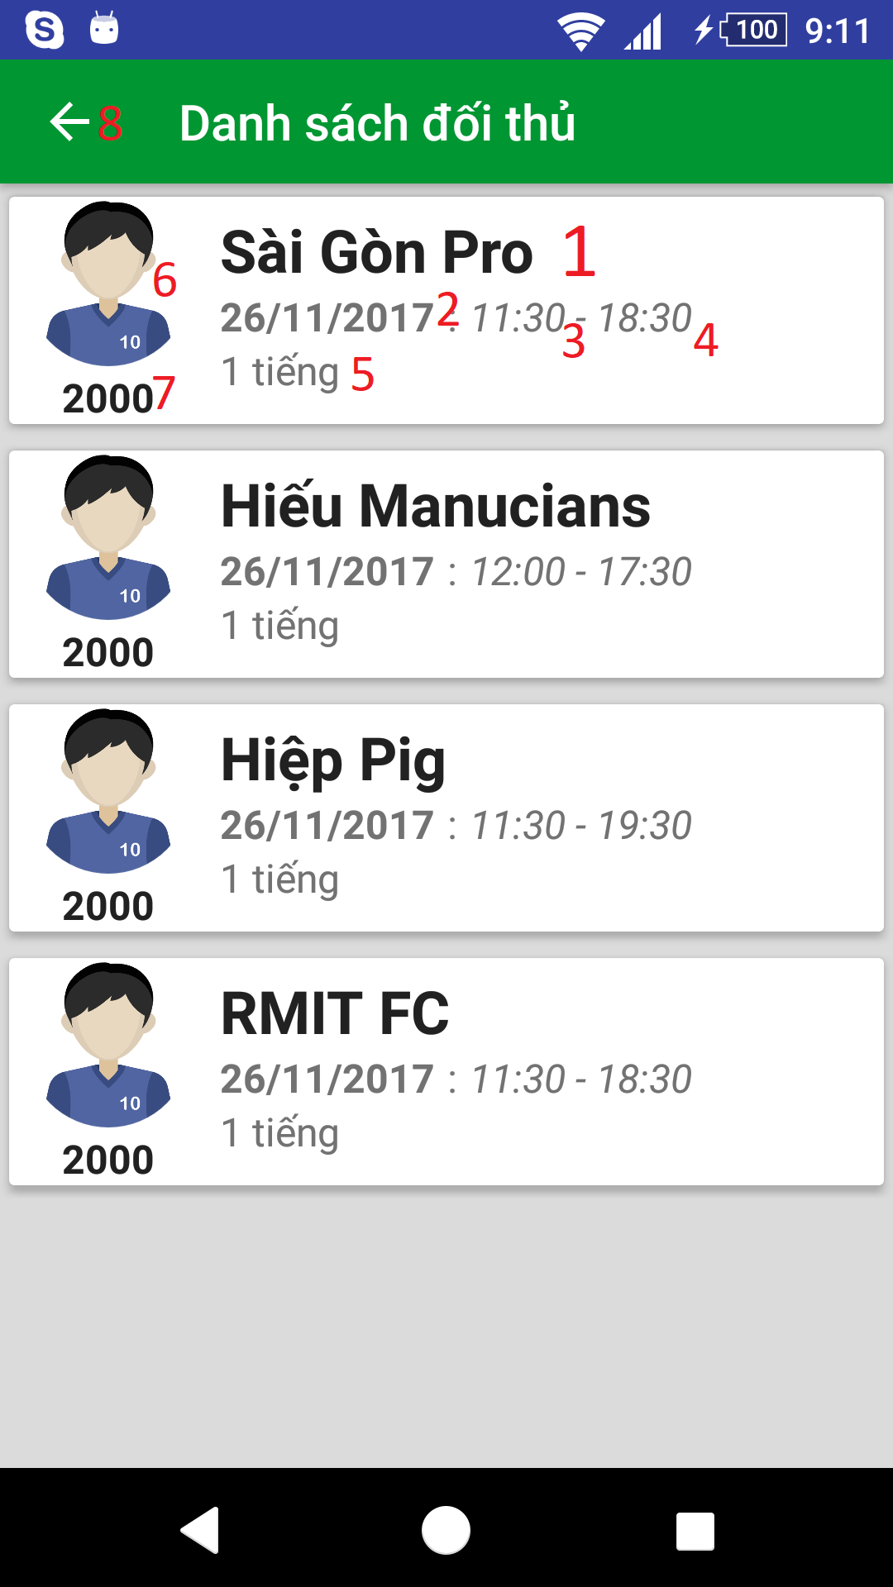

**Figure 105 – Matching result UI**

**Fields**

|  |  |  |  |  |  |  |
| --- | --- | --- | --- | --- | --- | --- |
| **No** | **Field Names** | **Description** | **Read Only** | **Mandatory** | **Control Type** | **Data Type** |
| 1 | teamName | User’s team name | Yes | Yes | TextView | String |
| 2 | date | Date | Yes | Yes | TextView | String |
| 3 | startTime | Start time | Yes | Yes | TextView | String |
| 4 | endTime | End time | Yes | Yes | TextView | String |
| 5 | duration | Duration | Yes | Yes | TextView | String |
| 6 | avatar | User’s avatar | Yes | Yes | ImageView | N/A |
| 7 | ratingScore | User’s rating score for ranking | Yes | Yes | TextView | String |

**Table 69 - <Mobile Application> Matching result Fields**

**Buttons/Hyperlinks:**

|  |  |  |  |  |
| --- | --- | --- | --- | --- |
| **No** | **Function** | **Description** | **Validation** | **Outcome** |
| 8 | goBack | Go back to previous view | N/A | Show previous view |

**Table 70 - <Mobile Application> Matching result Buttons/Hyperlinks**

**9. Recharge**

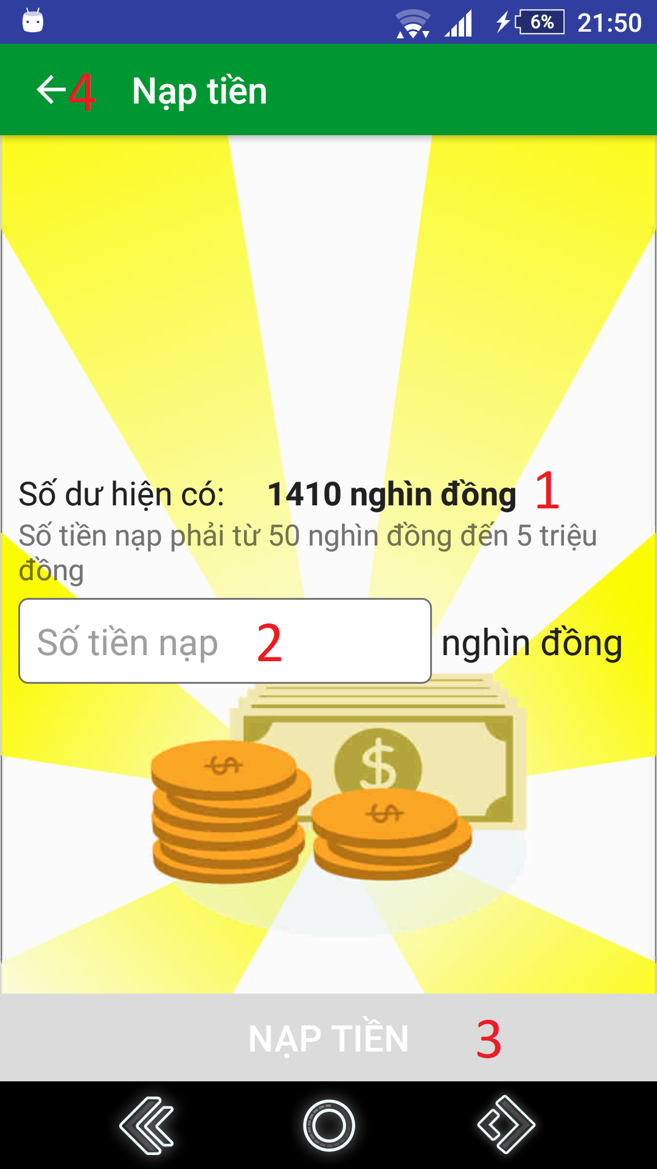

**Figure 105 – Recharge UI**

**Fields**

|  |  |  |  |  |  |  |
| --- | --- | --- | --- | --- | --- | --- |
| **No** | **Field Names** | **Description** | **Read Only** | **Mandatory** | **Control Type** | **Data Type** |
| 1 | balance | User’s current balance | Yes | Yes | TextView | String |
| 2 | rechargeMoney | Fill amount of money user wants to recharge | No | Yes | EditText | Integer |

**Table 71 - <Mobile Application> Recharge Fields**

**Buttons/Hyperlinks:**

|  |  |  |  |  |
| --- | --- | --- | --- | --- |
| **No** | **Function** | **Description** | **Validation** | **Outcome** |
| 3 | createNewRequest | Create new request | All fields required before summit | Show create new request result view |
| 4 | goBack | Go back to previous view | N/A | Show previous view |

**Table 72 - <Mobile Application> Recharge Buttons/Hyperlinks**

**10. Get reserved matches**

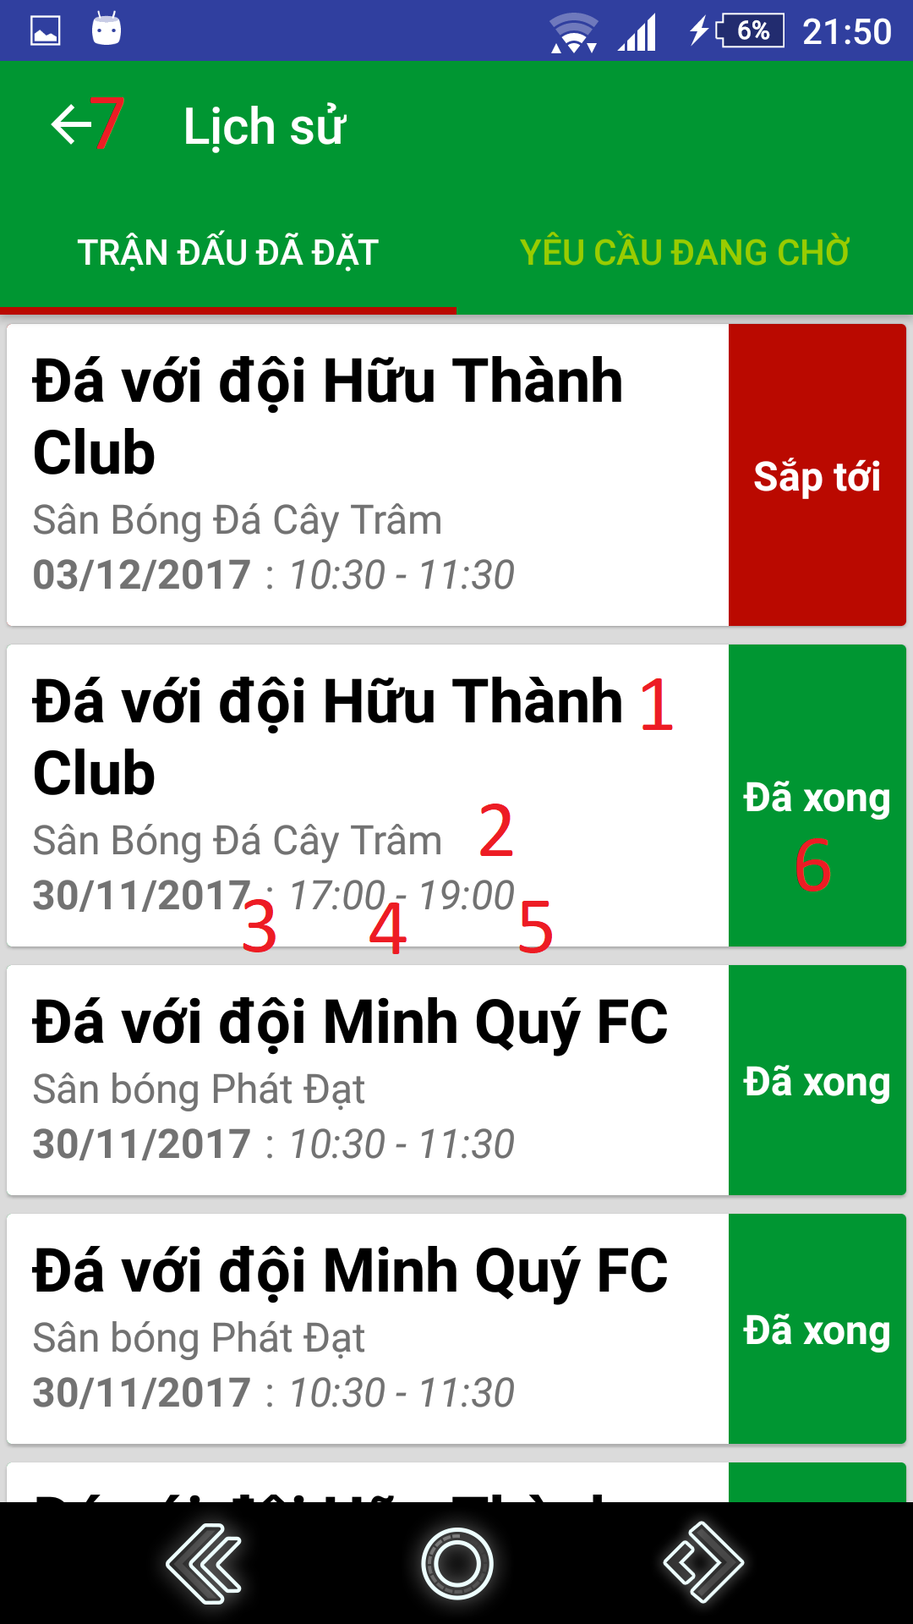

**Figure 105 – Get reserved matches UI**

**Fields**

|  |  |  |  |  |  |  |
| --- | --- | --- | --- | --- | --- | --- |
| **No** | **Field Names** | **Description** | **Read Only** | **Mandatory** | **Control Type** | **Data Type** |
| 1 | matchInfo | Information about match’s type and opponent’s team name played with (if have) | Yes | Yes | TextView | String |
| 2 | fieldName | Field name | Yes | Yes | TextView | String |
| 3 | date | Date | Yes | Yes | TextView | String |
| 4 | startTime | Start time | Yes | Yes | TextView | String |
| 5 | endTime | End time | Yes | Yes | TextView | String |
| 6 | status | Match’s status | Yes | Yes | TextView | String |

**Table 73 - <Mobile Application> Get reserved matches Fields**

**Buttons/Hyperlinks:**

|  |  |  |  |  |
| --- | --- | --- | --- | --- |
| **No** | **Function** | **Description** | **Validation** | **Outcome** |
| 7 | goBack | Go back to previous view | N/A | Show previous view |

**Table 74 - <Mobile Application> Get reserved matches Buttons/Hyperlinks**

**11. Get pending requests**

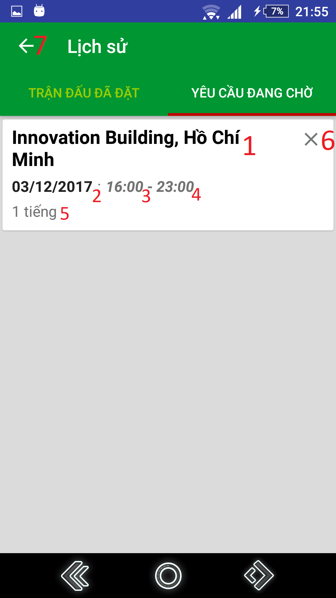

**Figure 105 – Get pending requests UI**

**Fields**

|  |  |  |  |  |  |  |
| --- | --- | --- | --- | --- | --- | --- |
| **No** | **Field Names** | **Description** | **Read Only** | **Mandatory** | **Control Type** | **Data Type** |
| 1 | address | Address where user create requests | Yes | Yes | TextView | String |
| 2 | date | Date | Yes | Yes | TextView | String |
| 3 | startTime | Start time | Yes | Yes | TextView | String |
| 4 | endTime | End time | Yes | Yes | TextView | String |
| 5 | duration | Duration | Yes | Yes | TextView | String |

**Table 75 - <Mobile Application> Get pending requests Fields**

**Buttons/Hyperlinks:**

|  |  |  |  |  |
| --- | --- | --- | --- | --- |
| **No** | **Function** | **Description** | **Validation** | **Outcome** |
| 6 | cancelRequest | Cancel Request | N/A | Refresh view pending matches view |
| 7 | goBack | Go back to previous view | N/A | Show previous view |

**Table 76 - <Mobile Application> Get pending requests Buttons/Hyperlinks**

**12. Rate field**

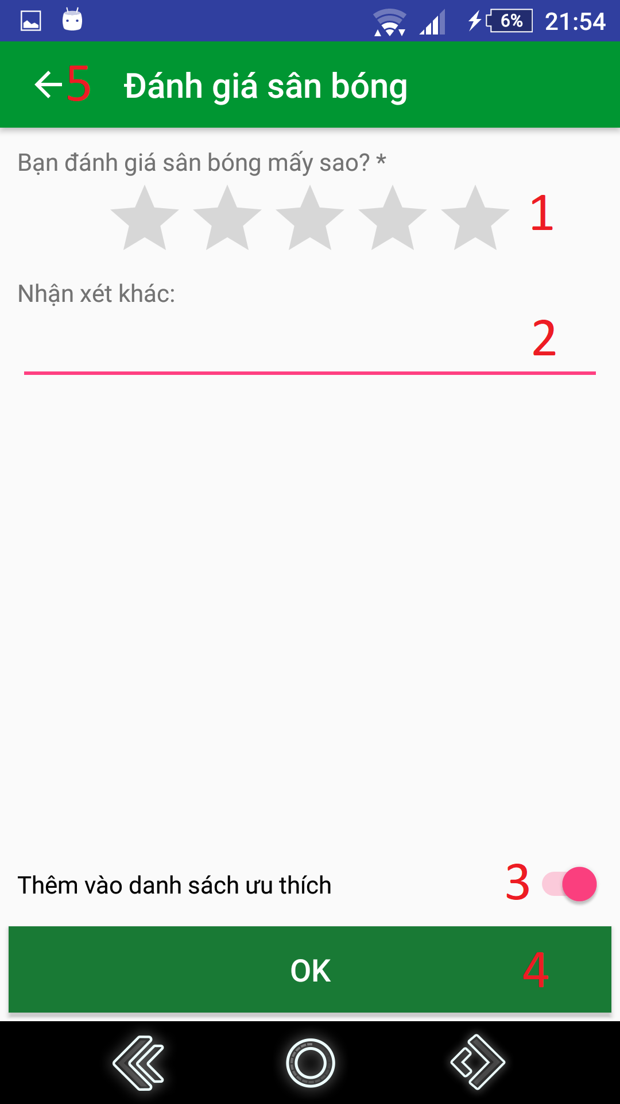

**Figure 105 – Rate field UI**

**Fields**

|  |  |  |  |  |  |  |
| --- | --- | --- | --- | --- | --- | --- |
| **No** | **Field Names** | **Description** | **Read Only** | **Mandatory** | **Control Type** | **Data Type** |
| 1 | ratingScore | Input user’s rating score about field’s quality | No | Yes | RatingBar | Float |
| 2 | comments | Input comments | No | No | EditText | String |

**Table 77 - <Mobile Application> Rate field Fields**

**Buttons/Hyperlinks:**

|  |  |  |  |  |
| --- | --- | --- | --- | --- |
| **No** | **Function** | **Description** | **Validation** | **Outcome** |
| 3 | setFavorite | Add/remove field to/from favorite list | All fields required before summit | Show setting result message. |
| 4 | submitRating | Submit field rating | All fields required before summit | Show submit rating result message. |
| 5 | goBack | Go back to previous view | N/A | Show previous view |

**Table 78 - <Mobile Application> Rate field Buttons/Hyperlinks**

**13. Rate opponent**

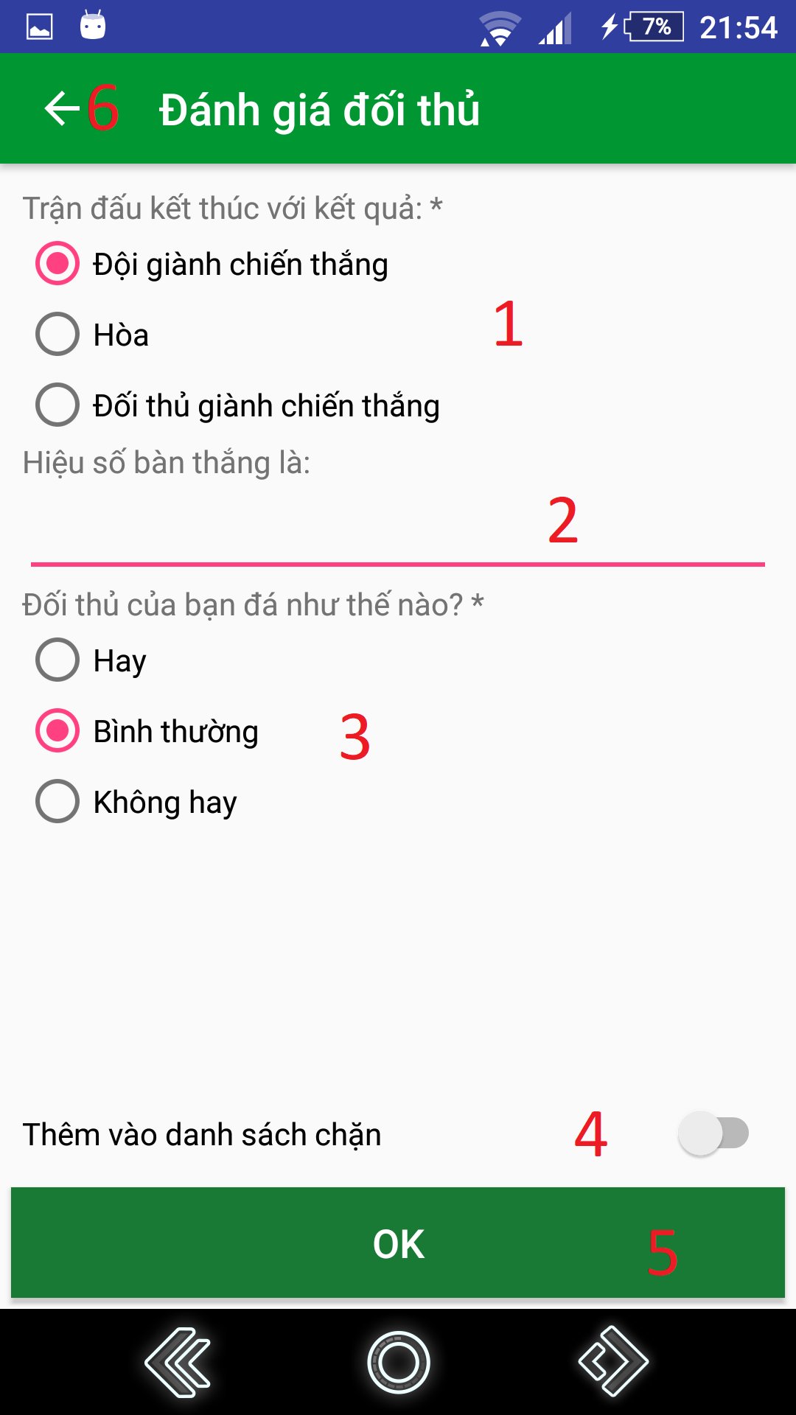

**Figure 105 – Rate opponent UI**

**Fields**

|  |  |  |  |  |  |  |
| --- | --- | --- | --- | --- | --- | --- |
| **No** | **Field Names** | **Description** | **Read Only** | **Mandatory** | **Control Type** | **Data Type** |
| 1 | winner | Input the match result | No | Yes | RadioButton | String |
| 2 | goalDifference | Input the match’s goal difference | No | No | EditText | Integer |
| 3 | opponentSkill | Input opponent’s performance in the match | No | Yes | RadioButton | String |

**Table 79 - <Mobile Application> Rate opponent Fields**

**Buttons/Hyperlinks:**

|  |  |  |  |  |
| --- | --- | --- | --- | --- |
| **No** | **Function** | **Description** | **Validation** | **Outcome** |
| 4 | setBlacklist | Add opponent to blacklist | All fields required before summit | Show setting result message. |
| 5 | submitRating | Submit opponent rating | All fields required before summit | Show submit rating result message. |
| 6 | goBack | Go back to previous view | N/A | Show previous view |

**Table 80 - <Mobile Application> Rate opponent Buttons/Hyperlinks**

**14. Report opponent**

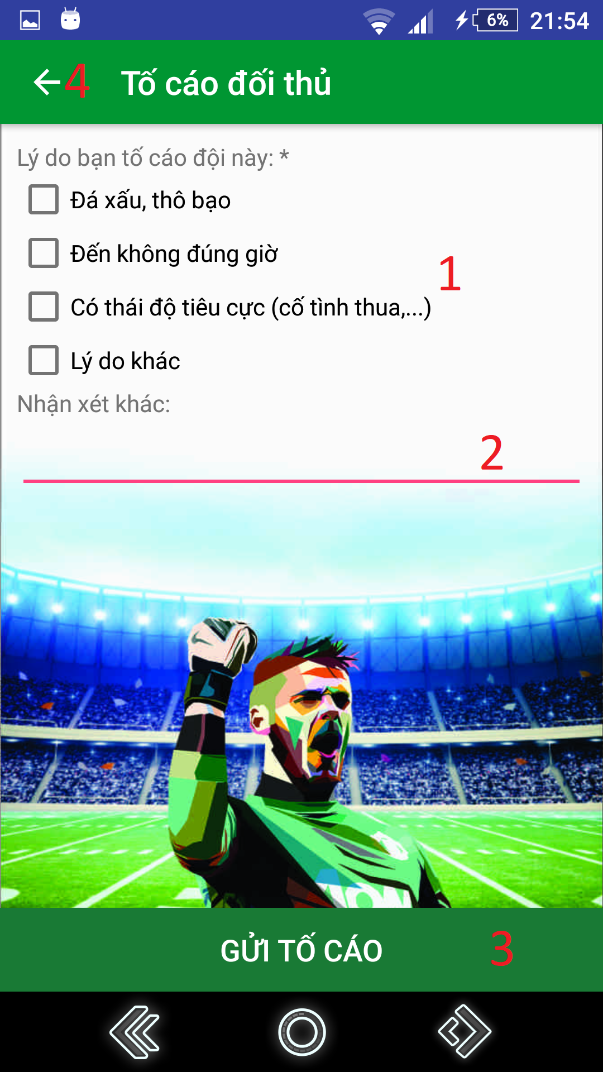

**Figure 105 – Report opponent UI**

**Fields**

|  |  |  |  |  |  |  |
| --- | --- | --- | --- | --- | --- | --- |
| **No** | **Field Names** | **Description** | **Read Only** | **Mandatory** | **Control Type** | **Data Type** |
| 1 | presetReasons | Input report reasons. | No | Yes | CheckBox | String |
| 2 | comments | Input comments. | No | No | EditText | String |

**Table 81 - <Mobile Application> Report opponent Fields**

**Buttons/Hyperlinks:**

|  |  |  |  |  |
| --- | --- | --- | --- | --- |
| **No** | **Function** | **Description** | **Validation** | **Outcome** |
| 3 | submitReport | Submit opponent report | All fields required before summit | Show submit report result message. |
| 4 | goBack | Go back to previous view | N/A | Show previous view |

**Table 82 - <Mobile Application> Report opponent Buttons/Hyperlinks**